G.T.S PHOTO COLLECTIONS FOR THE VISITS

1. JOSPHINE CHILDRENS HOME VISIT 09/24/2017
2. VISIT TO THE HOME OF AGED ,SAGANA-KIRINYAGA-03/04/2019
3. JOPHINE CHILDRENS HOME VISIT,MURURI-KIRINYAGA- 08/02/2018
4. MURANGA RESCUE CENTRE-10/28/2019
5. WAMUMU REHABILITATAION CENTRE ,MWEA-KIRINYAGA

JOSPHINE CHILDRENS HOME VISIT

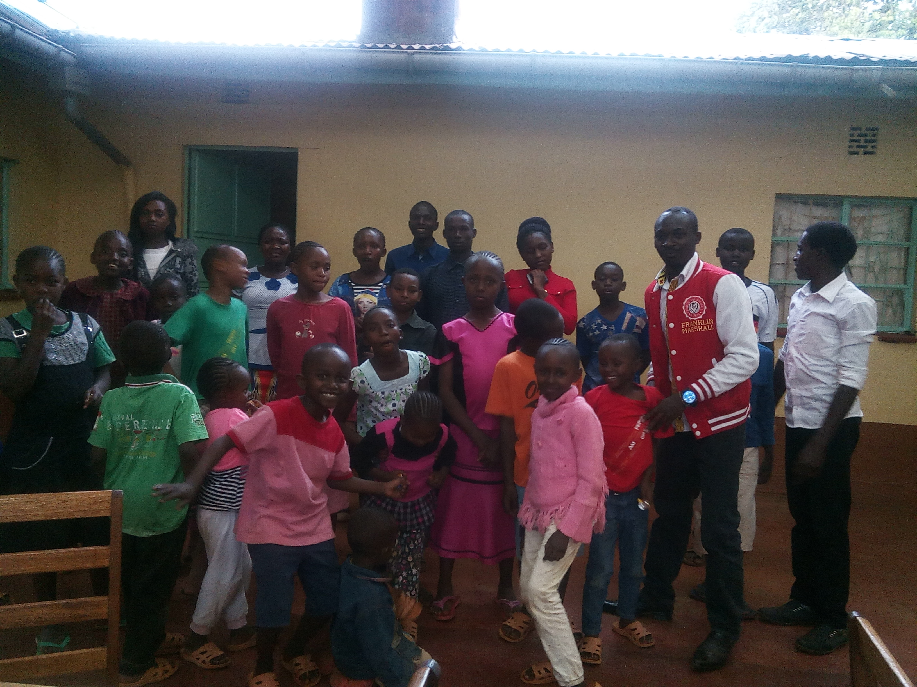

SEPTEMBER 24,2017

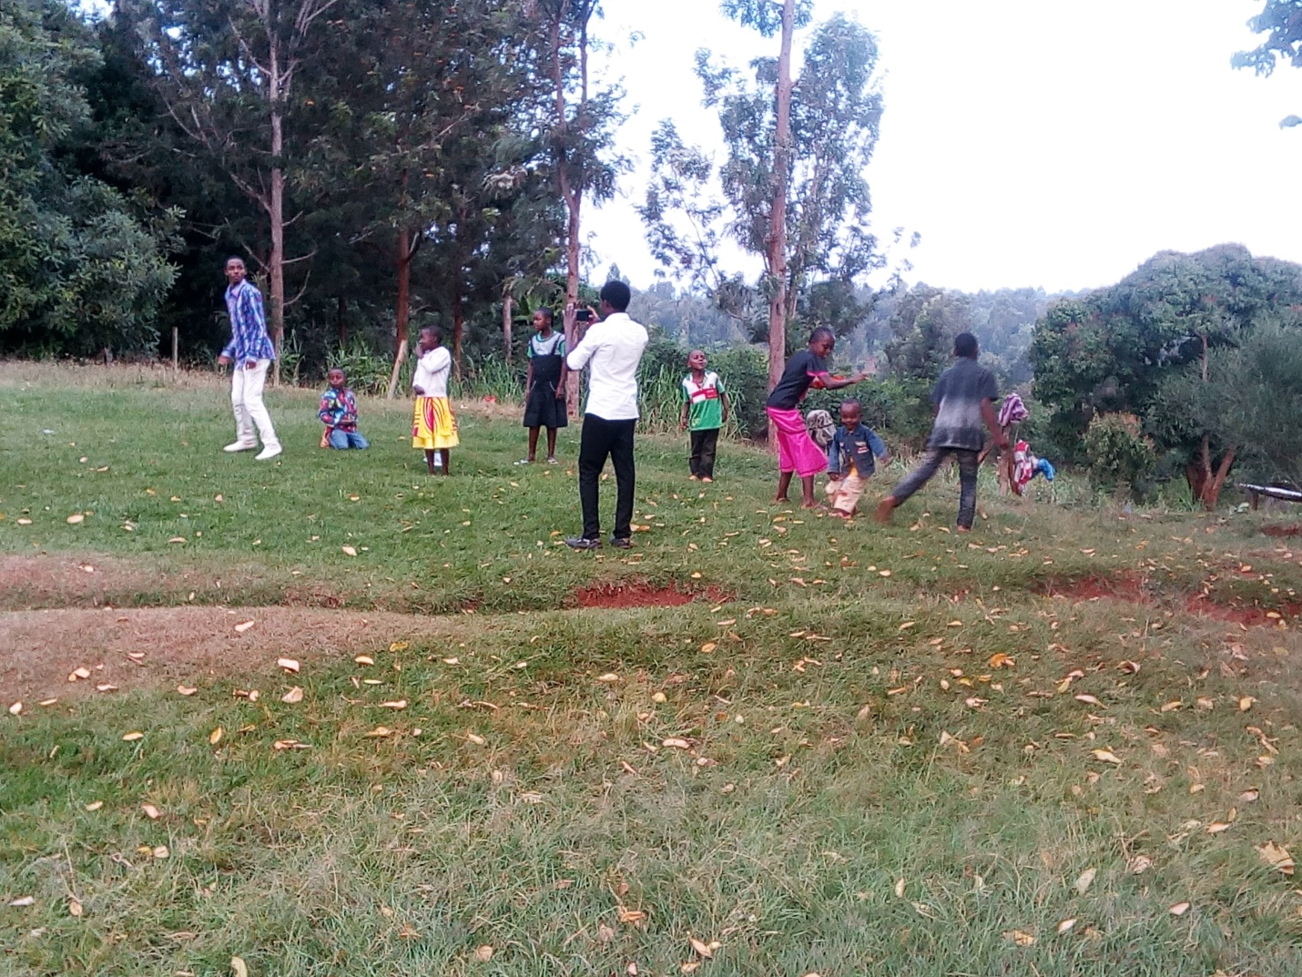

TEAM BUILDING -SEPTEMBER 24, 2017

**JOSPHINE CHILDREN HOME VISIT**

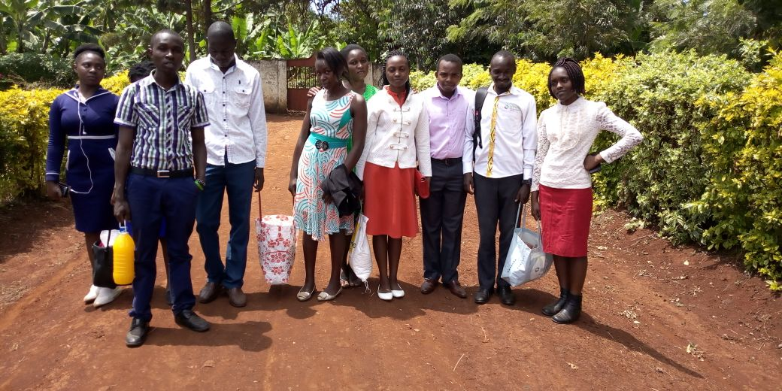

ARRIVAL- OCTOBER 4,2018

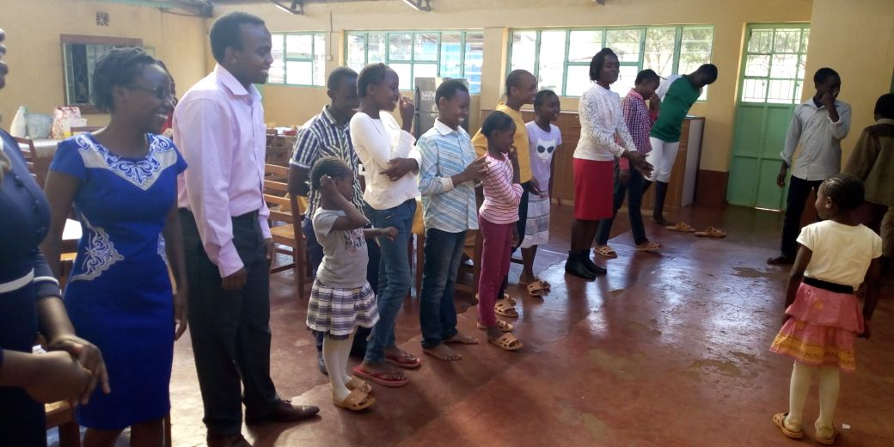

INTERACTION SESSION- OCTOBER 4,2018

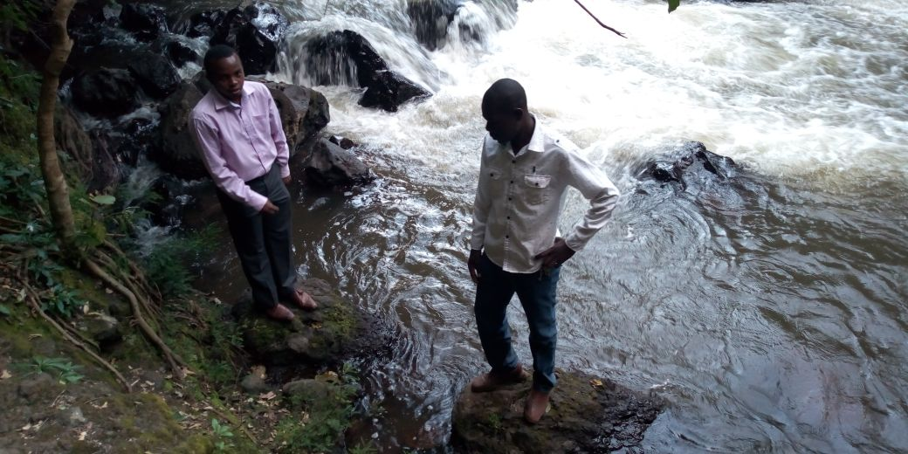

GOD’S BRIDGE ALONG THE VISIT OCTOBER 4, 2018

**VISIT TO THE AGED**

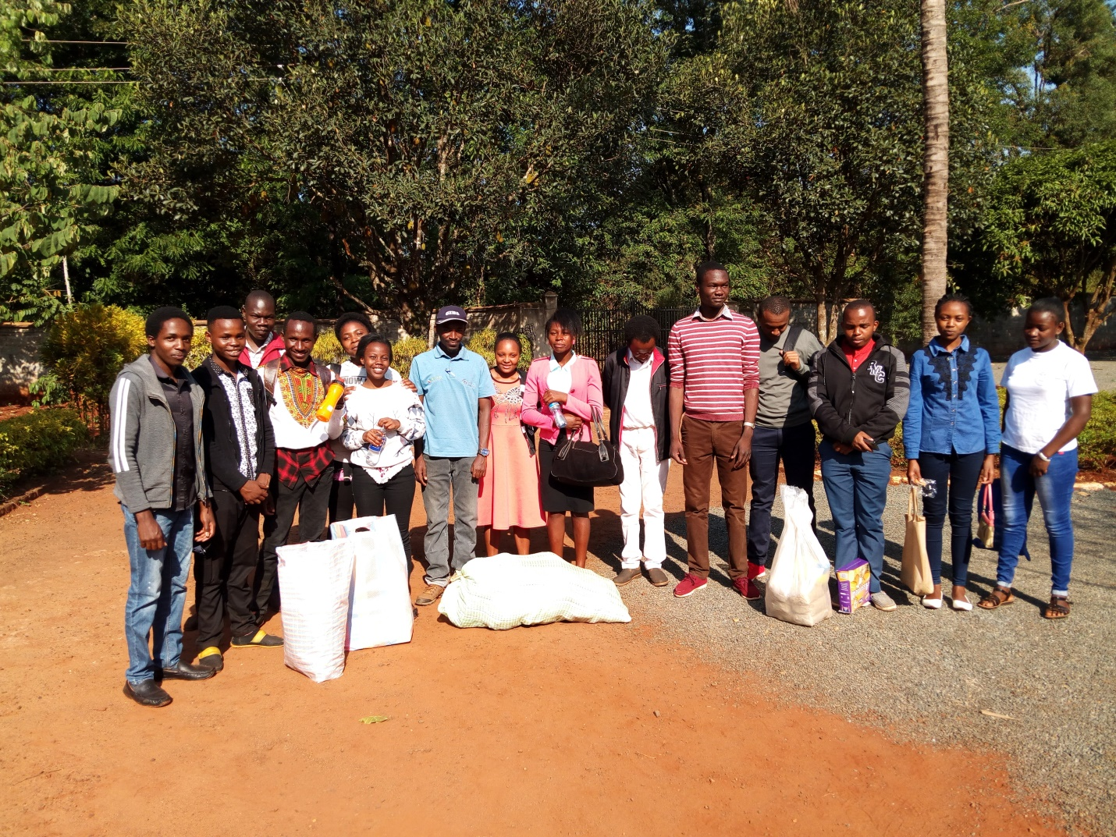

ARRIVAL-MARCH 2, 2019

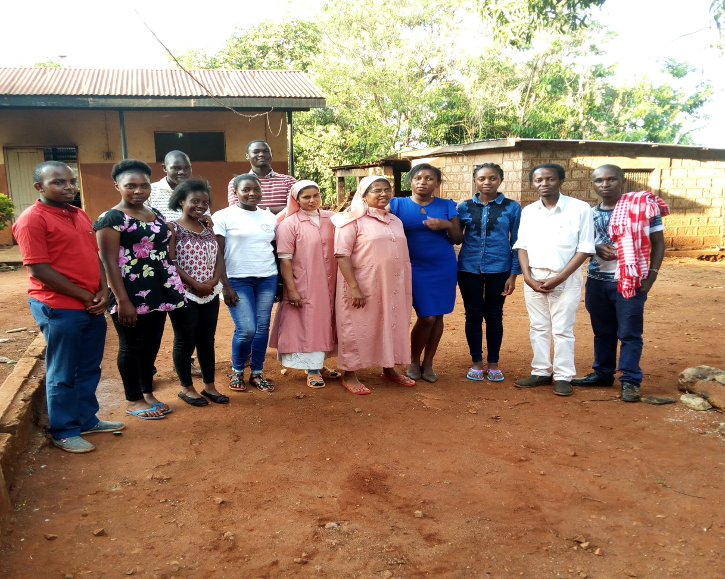

MARCH 2, 2019

**MURANGA RESCUE CENTRE**

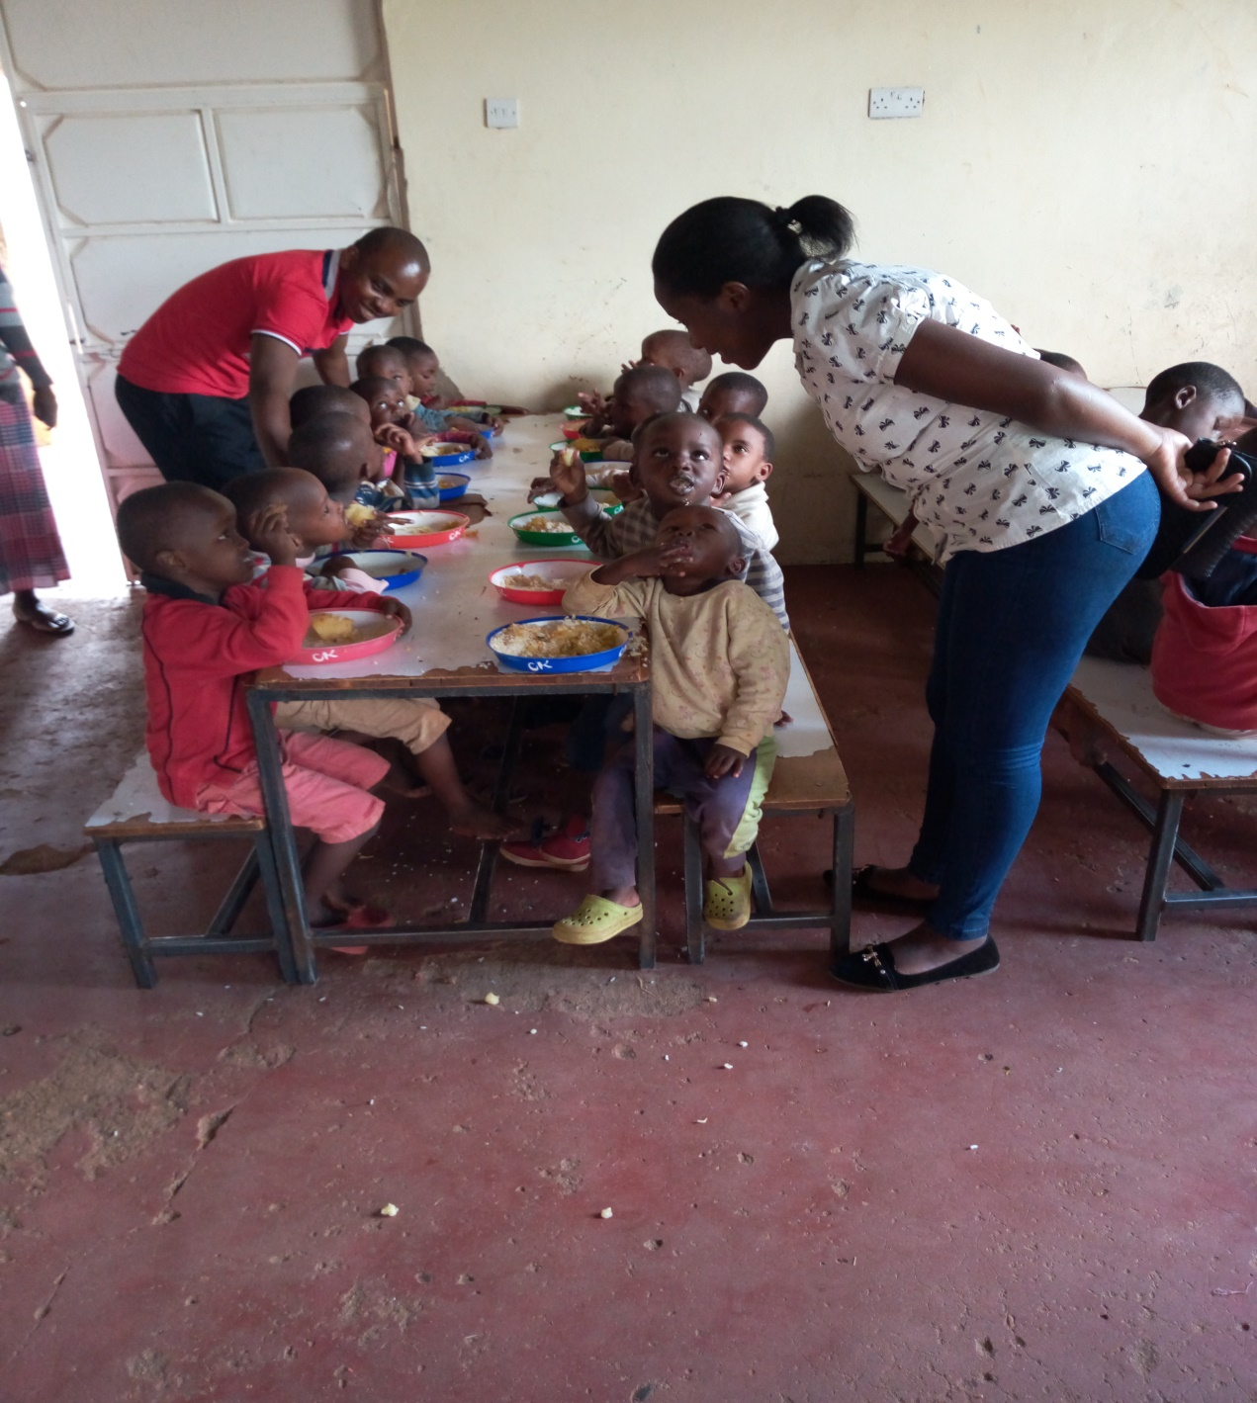

**0CTOBER 28, 2019**

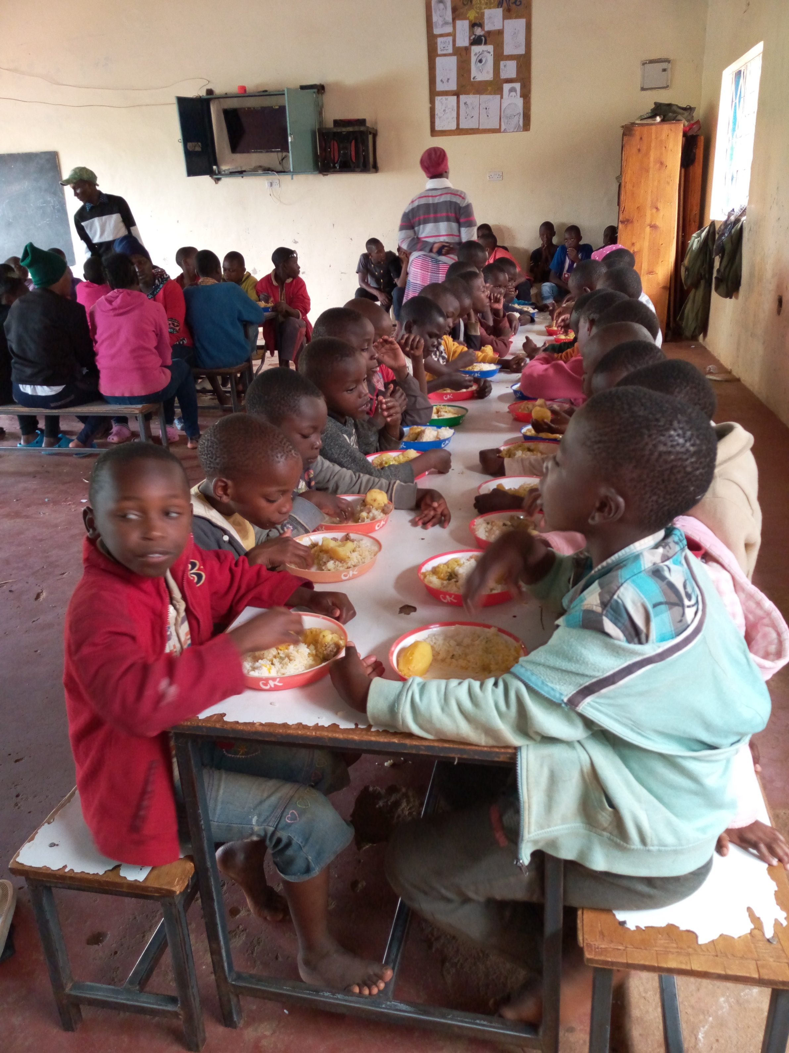

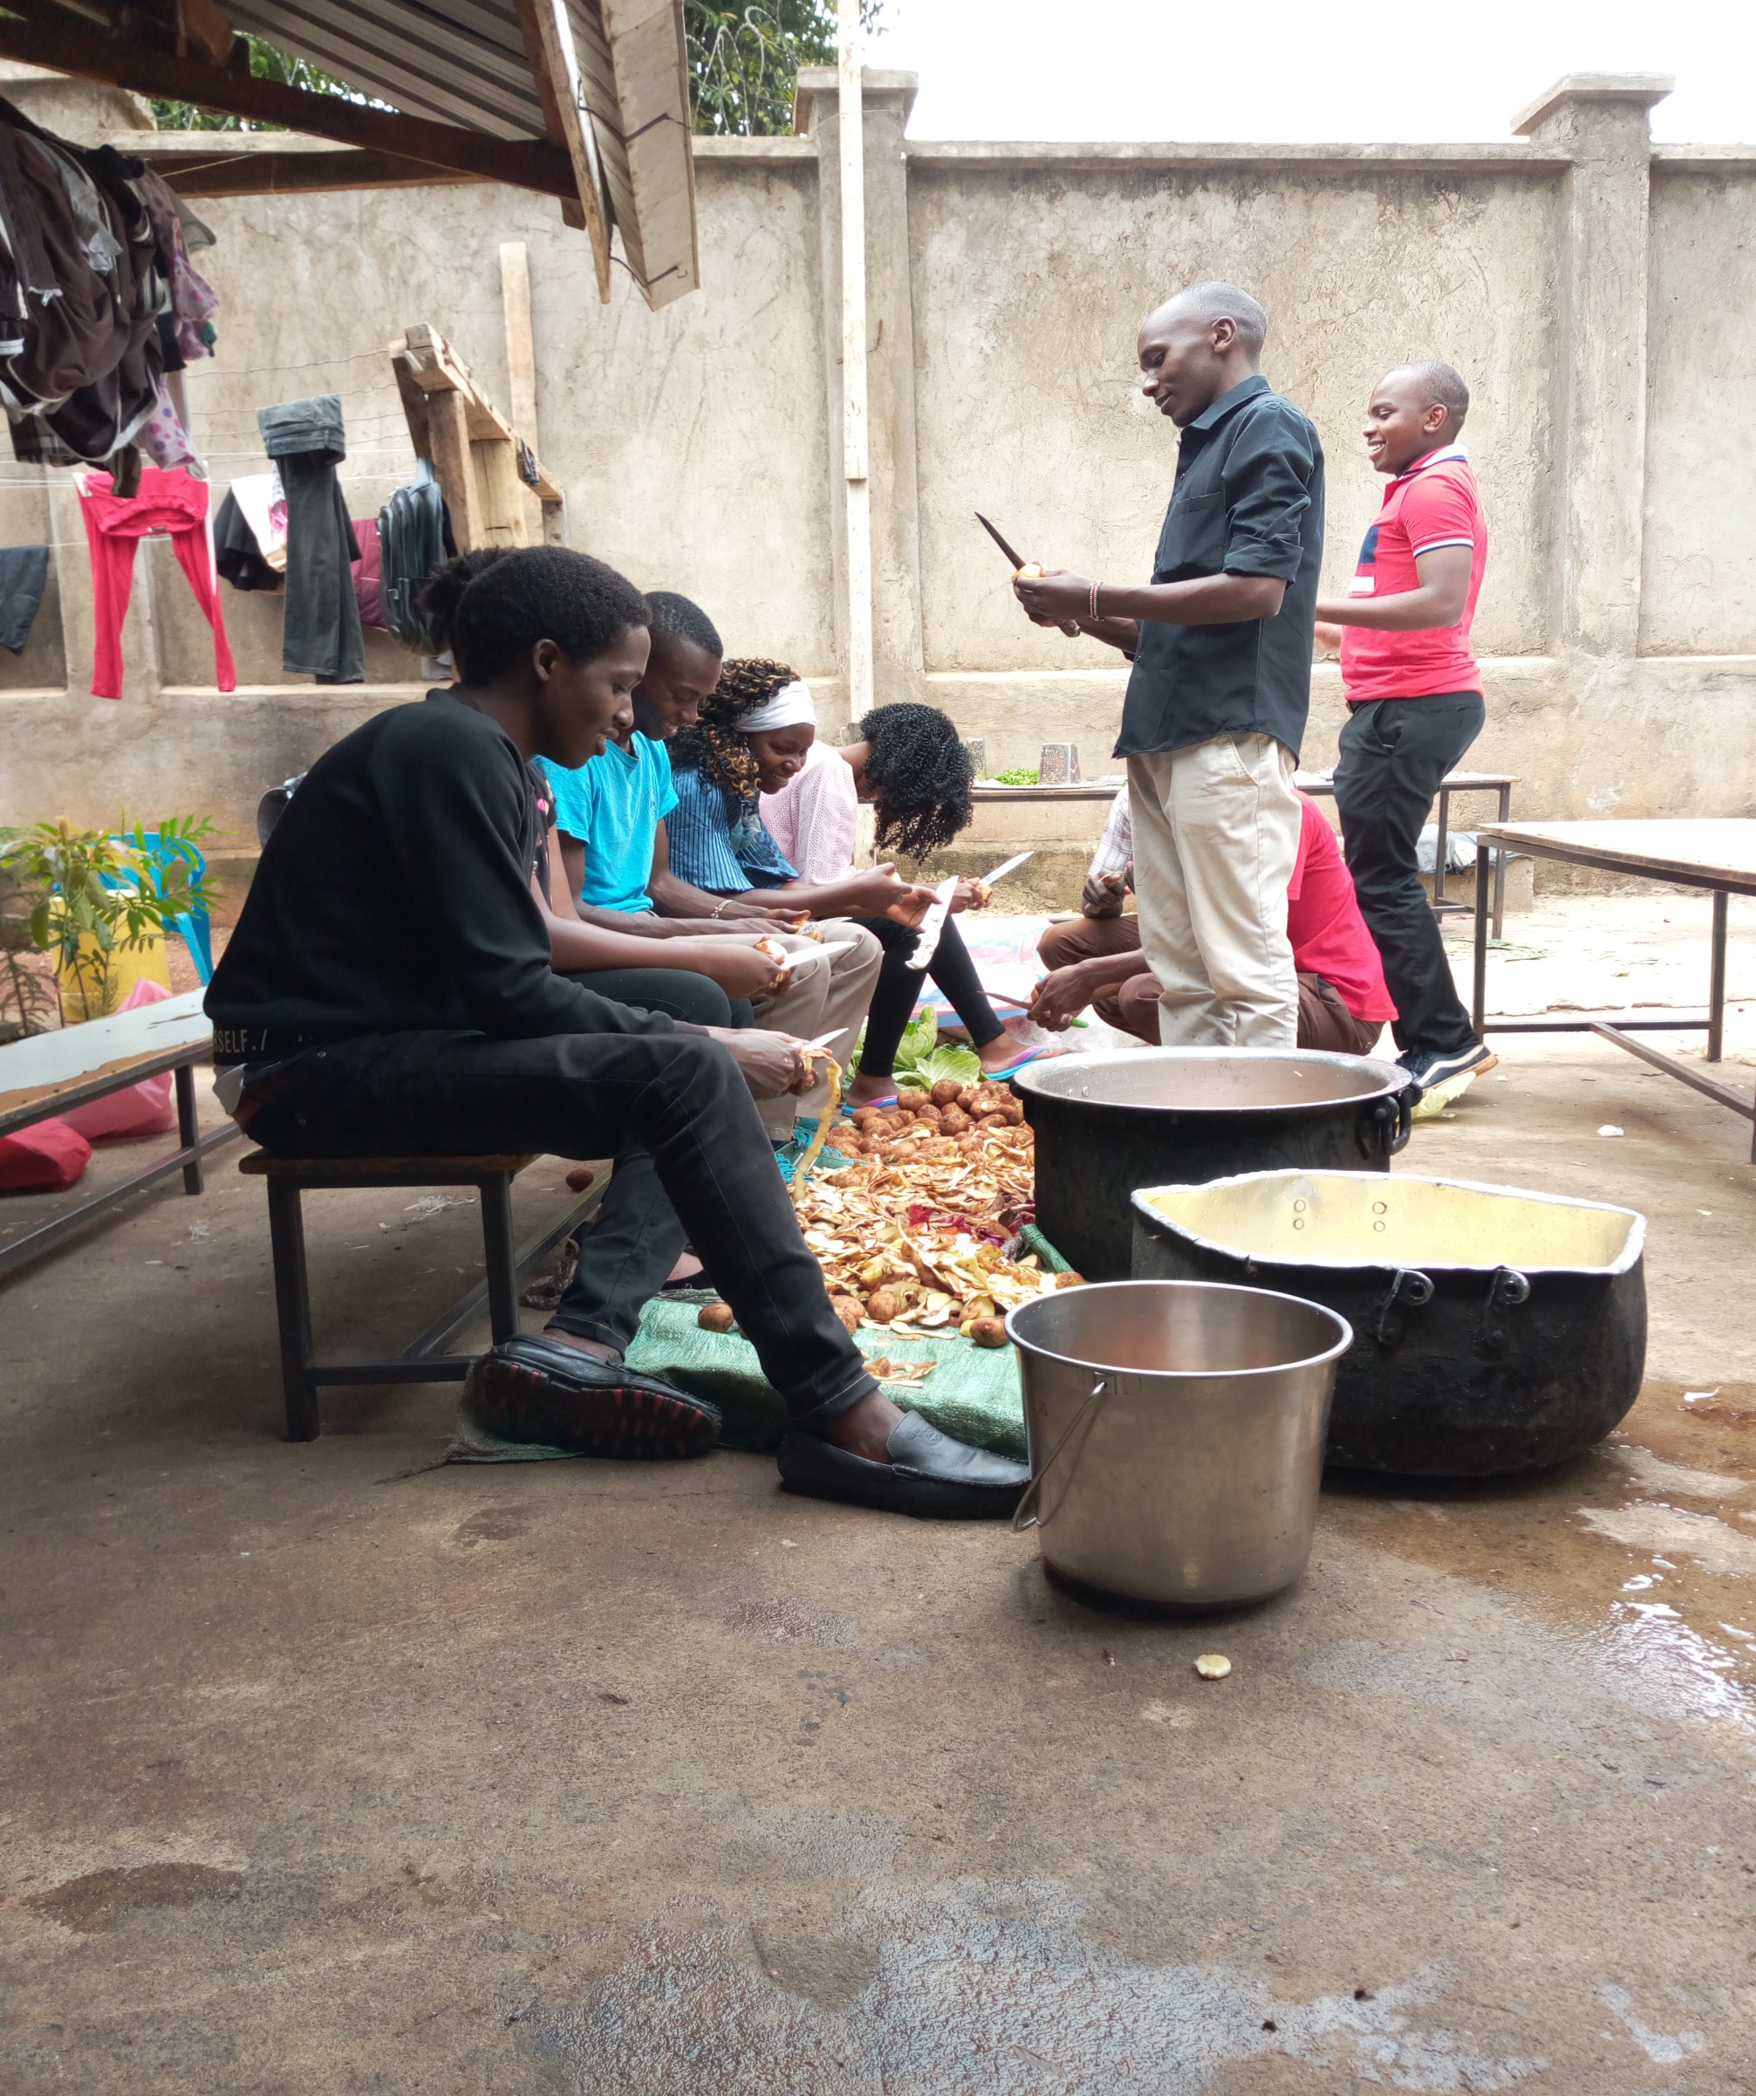

**Castle lodge at mt Kenya team building**

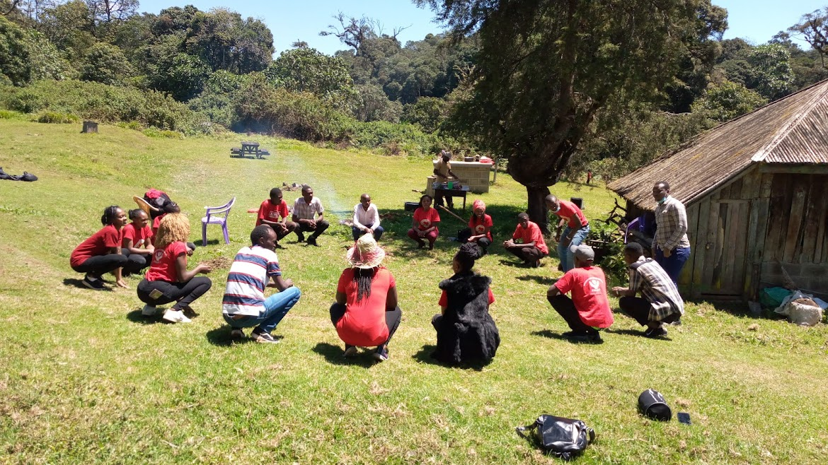

**Tree planting at mt Kenya**

**Gts11**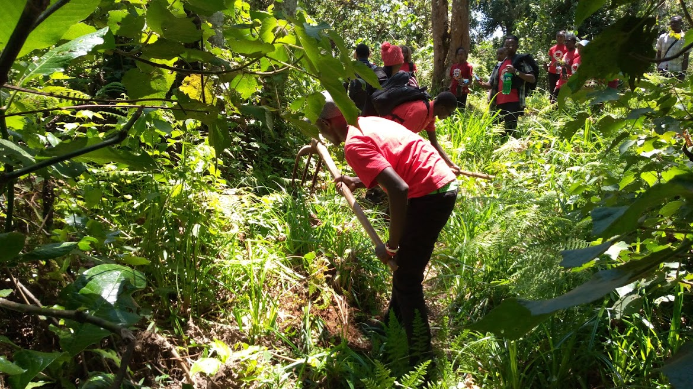

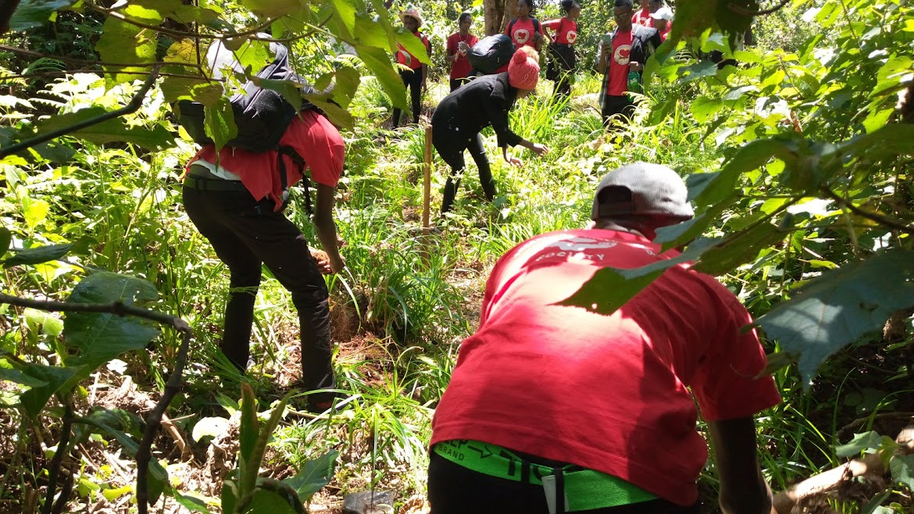

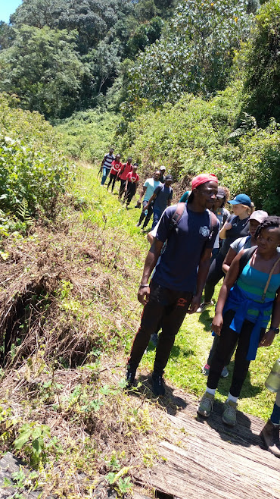

**Visit at Nyeri**



